How To Install VM Ware Workstation Pro

- Objective:

The objective of this lab is to download, install, and verify VMware Workstation Pro on a Windows computer. VMware allows you to create and run virtual machines, which you can use to build an isolated cybersecurity lab for learning Linux, network reconnaissance, and penetration testing.

- Requirements:
Before starting, check the following:

- A Windows 10 or Windows 11 computer.
- A 64-bit compatible processor with virtualization support.
- Administrator access to install software.
- Sufficient free disk space for VMware and virtual machines.
- At least 8 GB RAM recommended for a basic lab; 16 GB or more is preferable for running multiple VMs.
- An internet connection to download the installer.

Important: Virtualization must be enabled in your computer's BIOS/UEFI. On some systems, this setting is called Intel VT-x or Intel Virtualization Technology, or AMD-V/SVM Mode.

- Download VMware Workstation Pro:

The official website ,and Youtube Tutorial is :

https://www.vmware.com/products/desktop-hypervisor/workstation-and-fusion

https://youtu.be/iRObOcSjbFE?si=btwjE4CgsgF28eXK
https://drive.google.com/file/d/13XrQABLzPostMGUOmsAFcU0A5djMpP_i/view?usp=sharing

Follow these steps:
- Open the official download page.
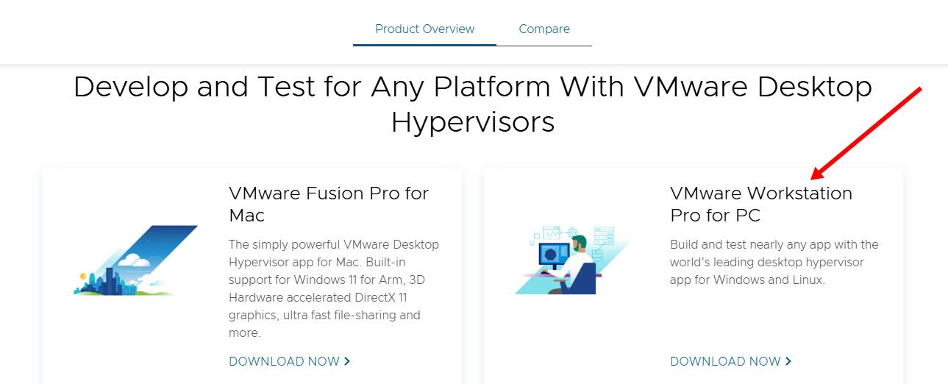

- Sign in to your Broadcom account, or register for a basic account.

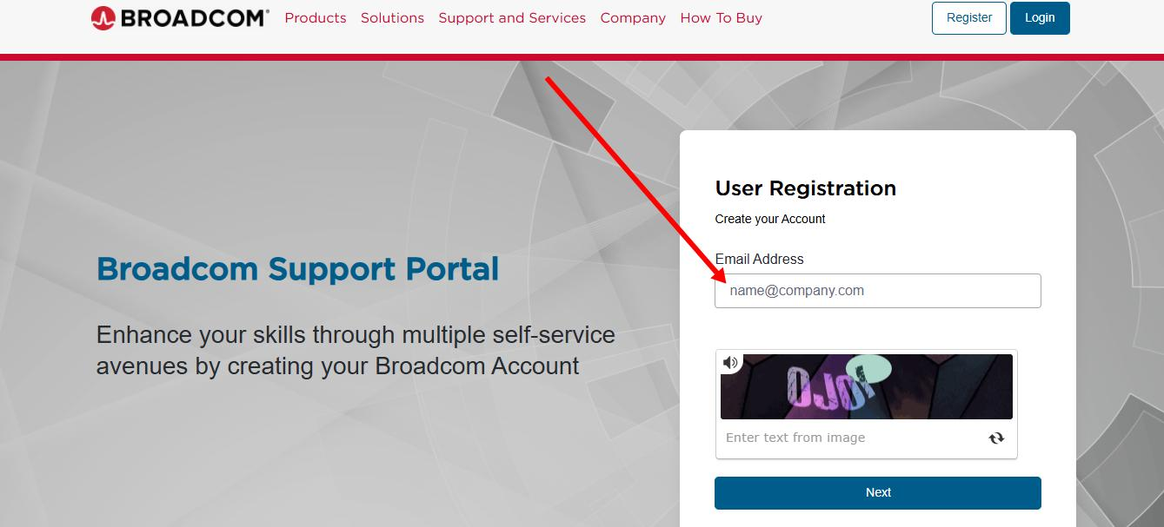

After Entering Email Verify your email by Copying the code from Email

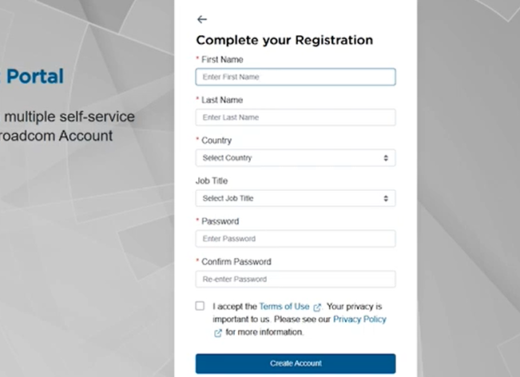

Login
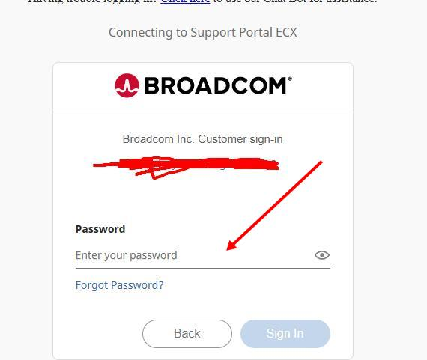

- Navigate to My Downloads → Free Software Downloads.

- Search for VMware Workstation Pro and select the latest stable Windows release available for your system.

Accept the terms and download the Windows installer, which should be an .exe file.

Step 1: Locate the installer
Open File Explorer and go to Downloads. Find the downloaded VMware installer.

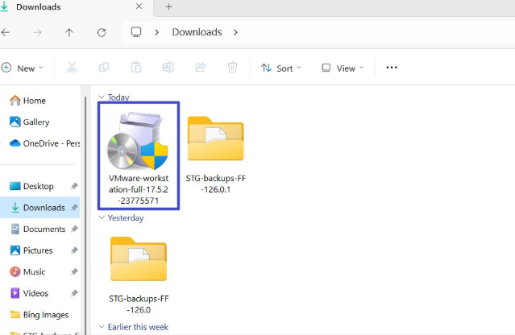

Step 2: Run the installer

Right-click the .exe file and select Run as administrator. Approve the Windows permission prompt if it appears.

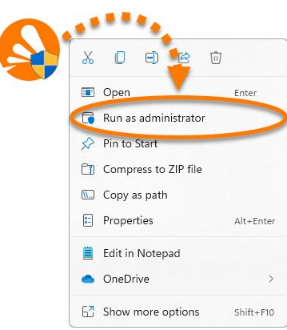

Step 5: Complete setup
Click Install, wait for the installation to finish, and restart your computer if prompted.
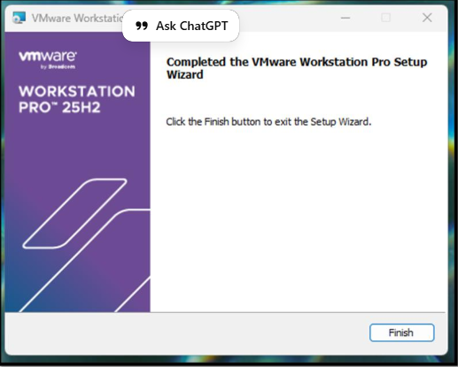
Note: Broadcom's account approval process can take time. If the download option is unavailable, check your account verification status.

